**More than 200 years of Nashville History**

Gender Representation in the Cemetery

Male vs. Female gender representation in the cemetery shows a clear trend of more female deaths over male deaths over time, however, there are exceptions. The years preceding the Civil War saw more male burials, but more females are buried at the cemetery from years of the war. Many men who died in combat were not buried in their hometowns, some bodies of soldiers were sent home after the war, but many remained in their original burial site. The only other exception occurs during the WW2, where for the second time since before the Civil War more men were buried then women.



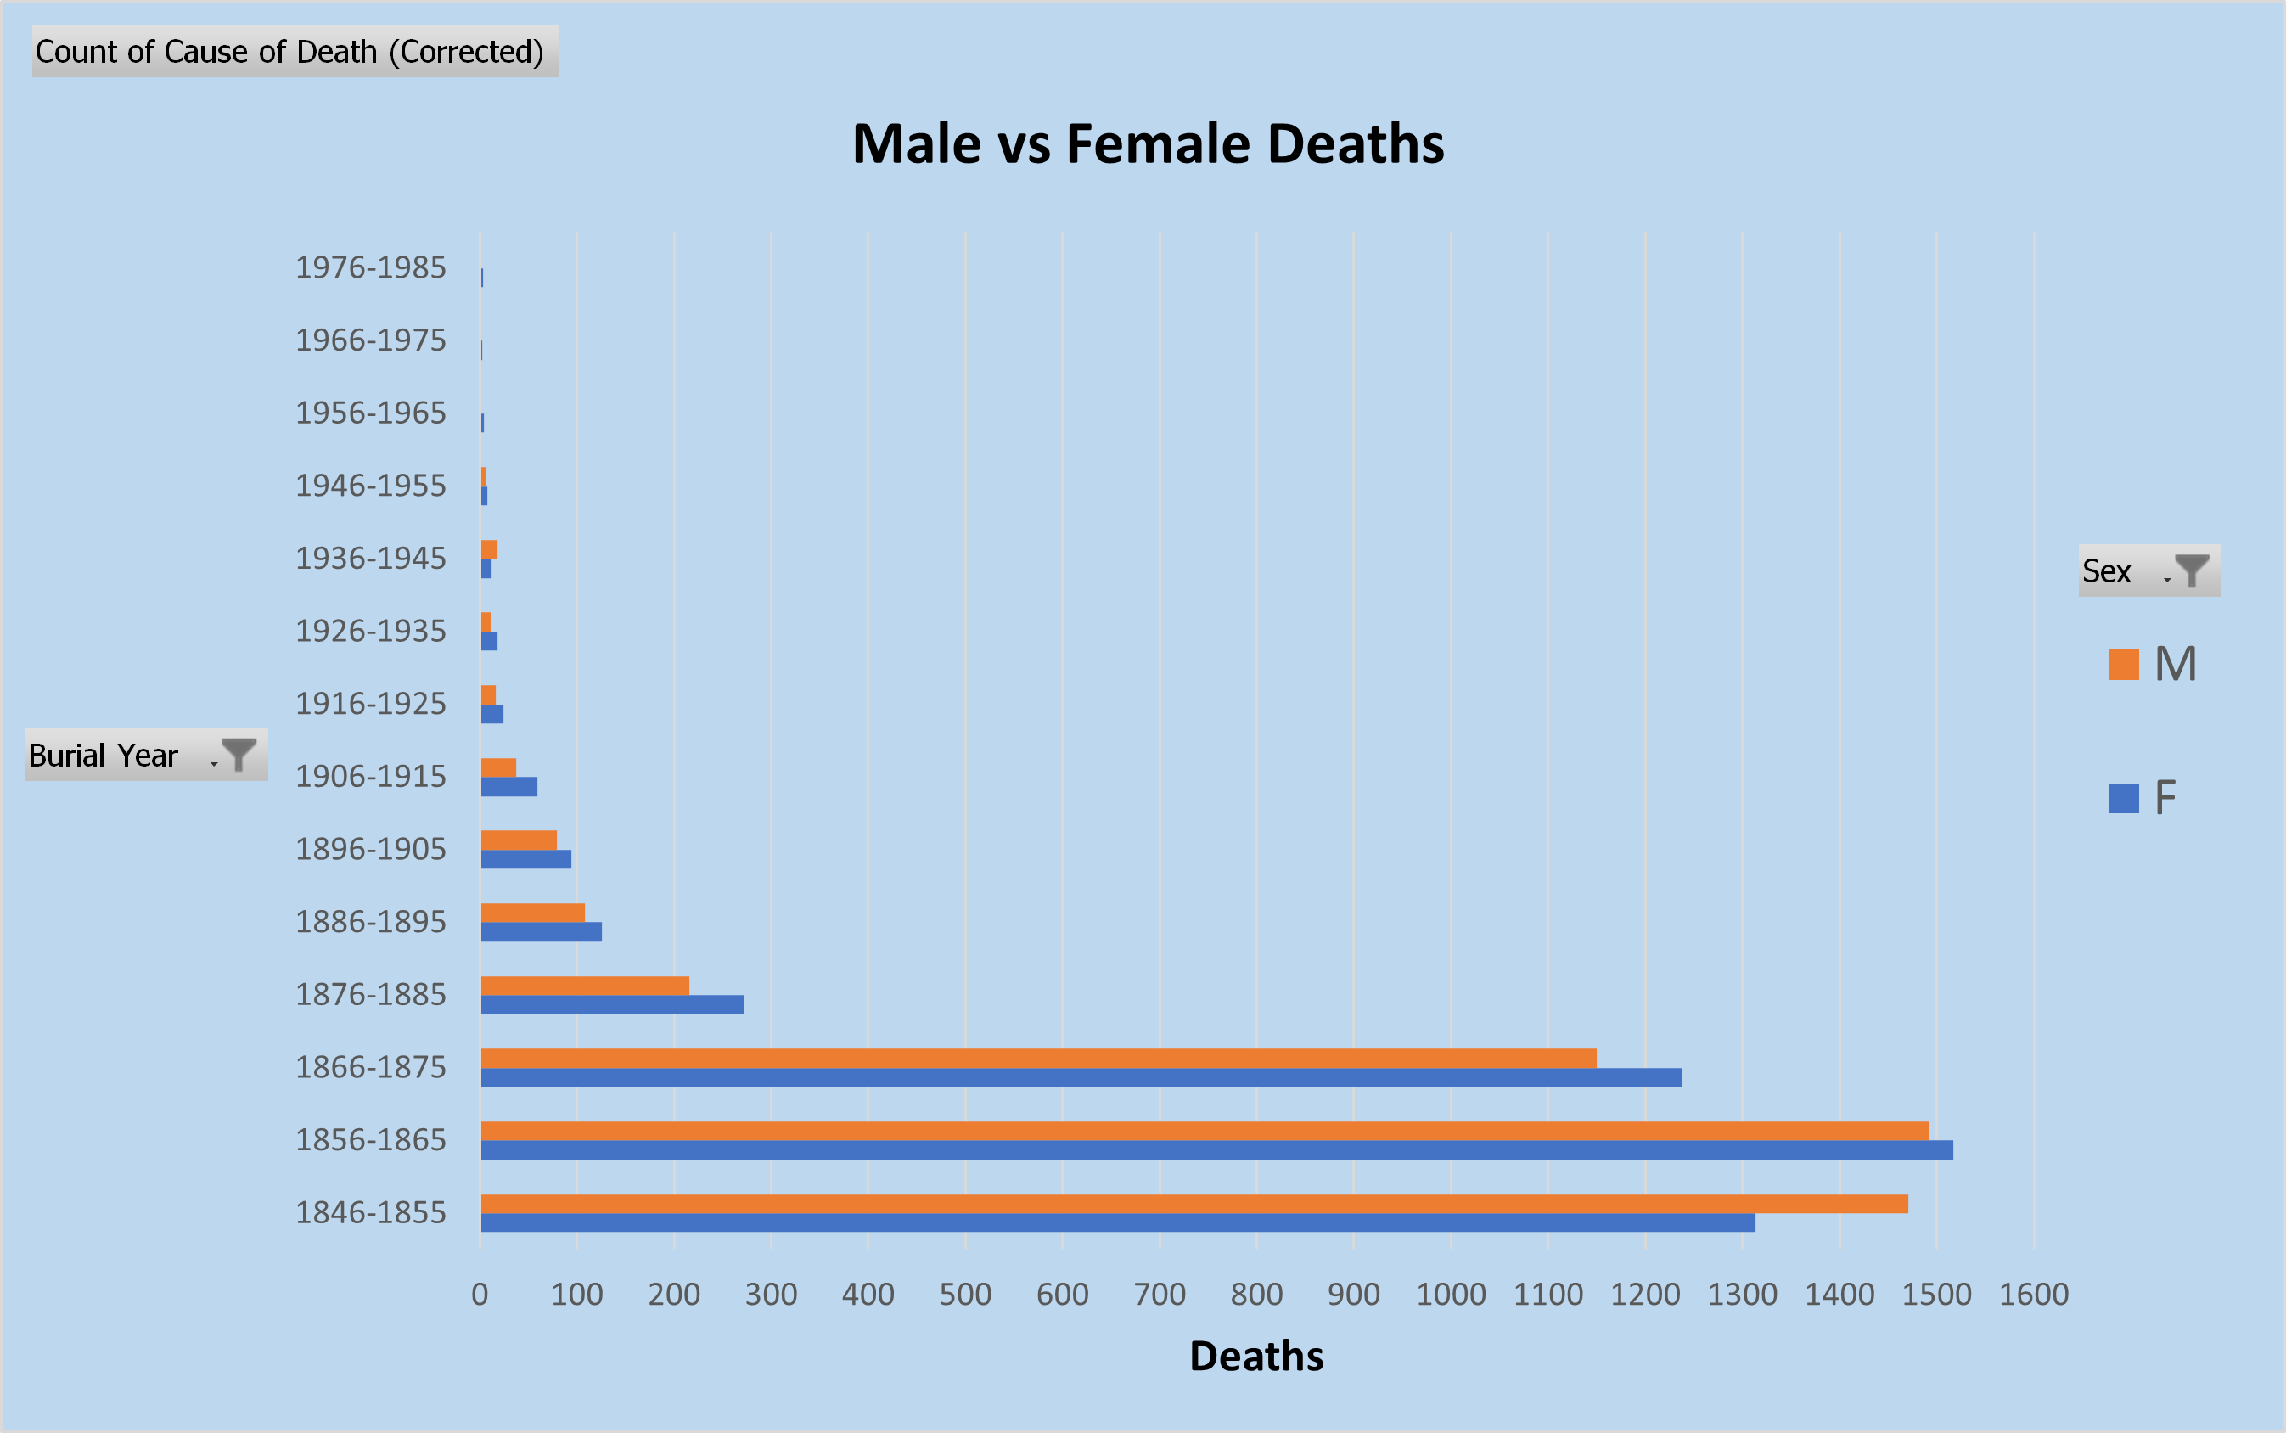

Why Did They Die?

With burials as early as 1822, The Nashville City Cemetery is the final resting place for nearly 20,000 men, women, and children. Amongst the buried are a variety of stories from Union soldiers to Cholera victims, infants who died at birth and an unusually high number of deaths due to teething issues.

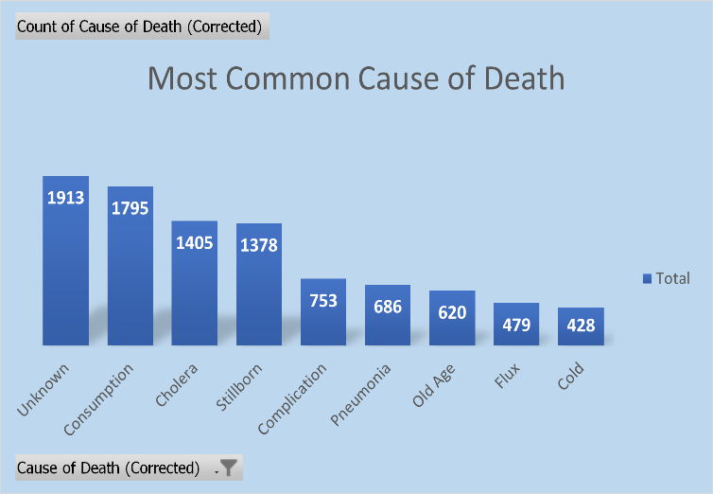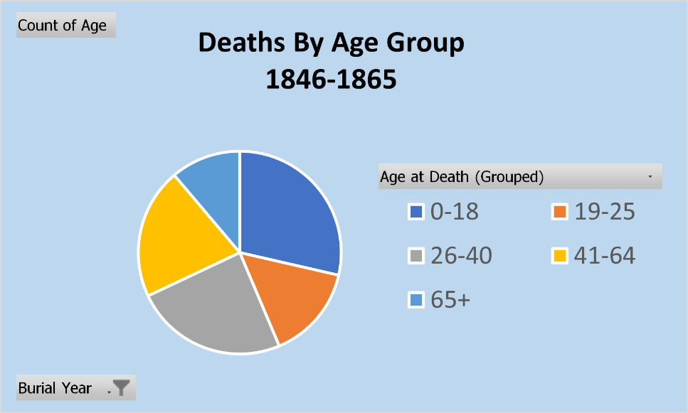

**Children Buried in the Cemetery**

More than 2500 children (0-18) are buried in the cemetery, and more than 1800 of those children were buried between 1846 & 1845 and make up one of the largest concentrated age groups. Stillborn births make up the largest count of child deaths accounted for in the cemetery.